Project Report
Implement Client Script & UI Policy (Incident)
Phase 6 — Final Project Report
Date | 01 October 2026
Team ID | SWTID-2026-4755
Project Name | Implement Client Script & UI Policy (Incident)
Maximum Marks | 5 Marks
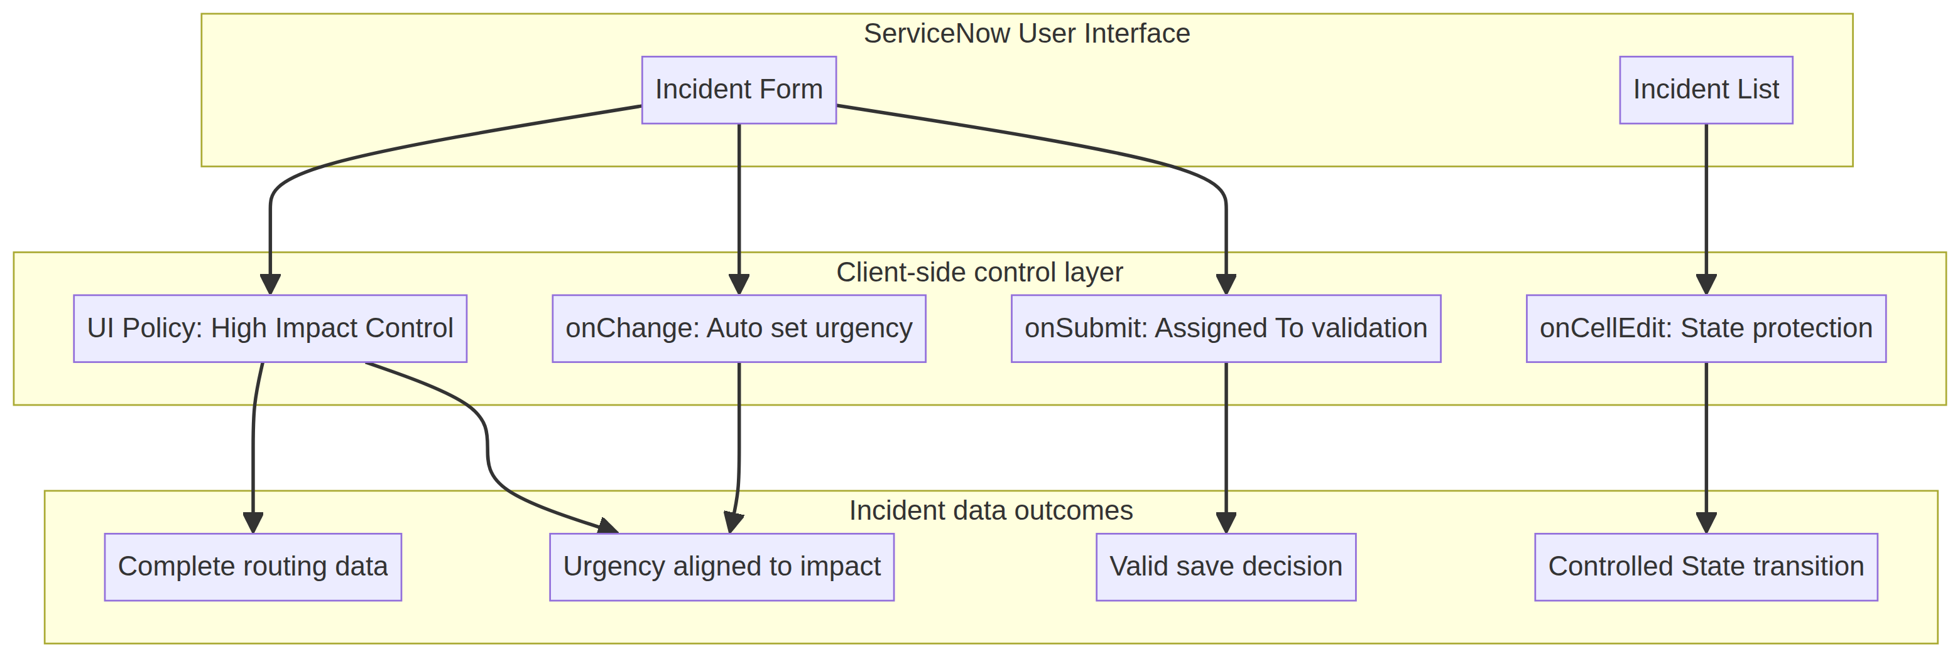
Figure 1. Project-specific solution architecture created from the supplied Incident implementation PDF.
Report scope: This final report documents the problem, ideation, requirements, design, planning, testing, results, trade-offs, conclusion, future scope, and source-code appendix for the ServiceNow Incident client-side control implementation. The report uses the supplied project PDF as the authoritative project basis and uses original diagrams instead of template images.
1. INTRODUCTION
1.1 Project Overview
Incident records are operational data objects used for triage, assignment, prioritization, communication, and resolution. The project implements a controlled Incident form experience in ServiceNow using one UI Policy and three Client Scripts. The controls respond to Impact, Assigned To, and State so that important records are completed consistently and unsafe edits are stopped before they affect service operations.
- UI Policy: High Impact Control on the Incident table, active when Impact is 1 – High.
- UI Policy Actions: Assignment group becomes mandatory and Urgency becomes read-only under the high-impact condition.
- onChange Client Script: sets Urgency to High when Impact changes to High and displays an information message.
- onSubmit Client Script: blocks save when a high-impact Incident has no Assigned To value.
- onCellEdit Client Script: blocks direct State changes from the Incident list while form-based changes remain possible.
1.2 Purpose
The purpose is to demonstrate a lightweight, maintainable approach to improving data integrity at the user-interface layer. The solution reduces dependence on memory and manual checking by turning business rules into immediate field behavior and save-time validation. It is intentionally scoped to the Incident table and to the fields needed for routing, urgency, ownership, and state control.
2. IDEATION PHASE
2.1 Problem Statement
Incident entry can become unreliable when users manually decide which fields must be completed, when priority-related values are not aligned, or when list editing bypasses the intended form workflow. Incomplete Assignment group or Assigned To information can delay routing. A user may also attempt to change State directly in a list without reviewing the full Incident context. These conditions can reduce reporting quality, weaken triage discipline, and create avoidable operational rework.
2.2 Empathy Map Canvas
The primary user is a service desk analyst or Incident coordinator who needs fast data entry but also needs the platform to protect the quality of high-impact records. The empathy map below converts that user context into design requirements.
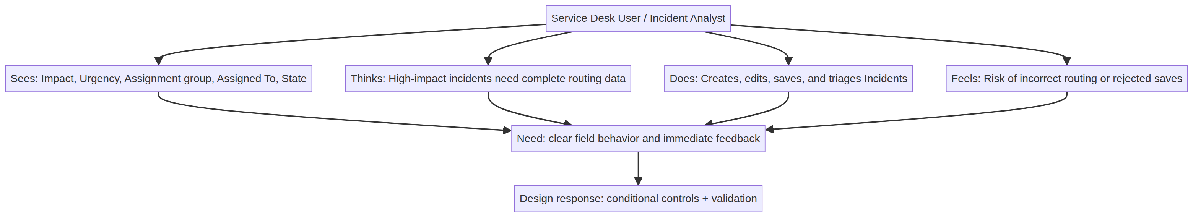
Figure 2. Empathy map for a ServiceNow Incident analyst using the controlled form.
User dimension | Observed context | User need | Design response
Sees | Impact, Urgency, Assignment group, Assigned To, and State fields | Know which fields require action | Dynamic mandatory and read-only behavior
Thinks | High-impact records need complete routing data | Trust that the record is ready for triage | Conditional policy and save validation
Does | Creates, edits, saves, and triages Incidents | Complete work without repeated manual checks | Automatic urgency update and clear feedback
Feels | Risk of incorrect routing or rejected saves | Receive immediate guidance instead of surprise errors | Info message, field error, and list-edit alert
2.3 Brainstorming
The ideation process considered several possible controls: mandatory fields, automatic value population, read-only protection, save-time validation, list-edit prevention, and server-side enforcement. The selected concept combines client-side controls because the project specifically demonstrates UI Policies and Client Scripts. The design keeps each behavior focused: the policy controls field state, the onChange script automates urgency, the onSubmit script protects save, and the onCellEdit script protects list interaction.
3. REQUIREMENT ANALYSIS
3.1 Customer Journey Map
The journey begins when a user opens or creates an Incident and ends when the record is saved or the user is redirected to correct an invalid entry. High Impact is the key decision point.
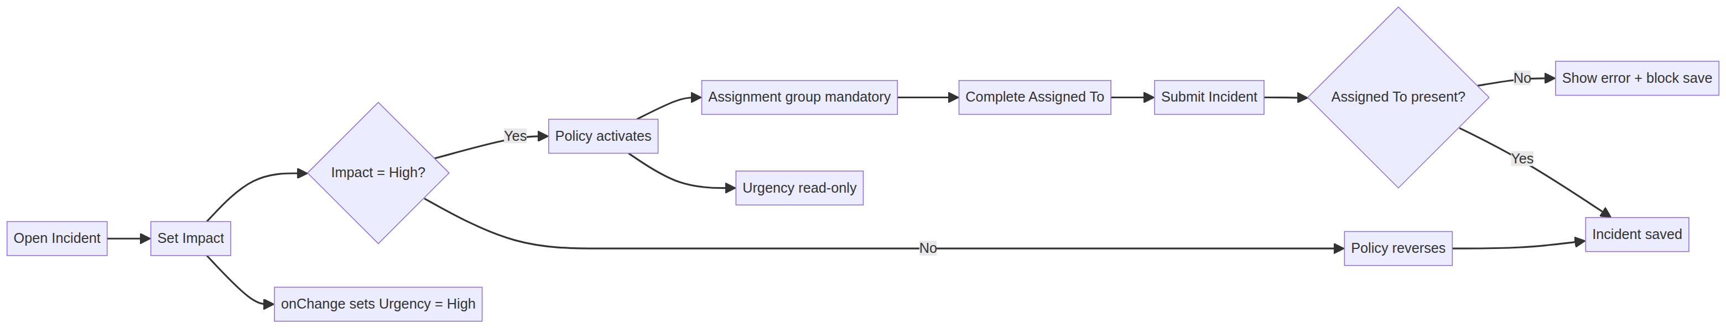
Figure 3. Customer journey from Impact selection to validated Incident save.
3.2 Solution Requirement
Requirement ID | Requirement | Implementation | Acceptance measure
REQ-01 | Activate controls when Incident Impact = 1 – High | UI Policy: High Impact Control | Policy condition evaluates true
REQ-02 | Make Assignment group mandatory for high impact | UI Policy Action with mandatory checked | Empty value is visibly required
REQ-03 | Make Urgency read-only for high impact | UI Policy Action Read-only = true | User cannot edit Urgency under condition
REQ-04 | Set Urgency to High automatically | onChange on Impact | Urgency becomes 1 and info message appears
REQ-05 | Prevent save when Assigned To is empty | onSubmit condition and showErrorBox | Return false blocks record submission
REQ-06 | Prevent State list editing | onCellEdit callback(false) | Alert appears and list value does not change
REQ-07 | Reverse temporary controls when condition clears | Reverse if false = true | Impact High → Medium restores editability
3.3 Data Flow Diagram
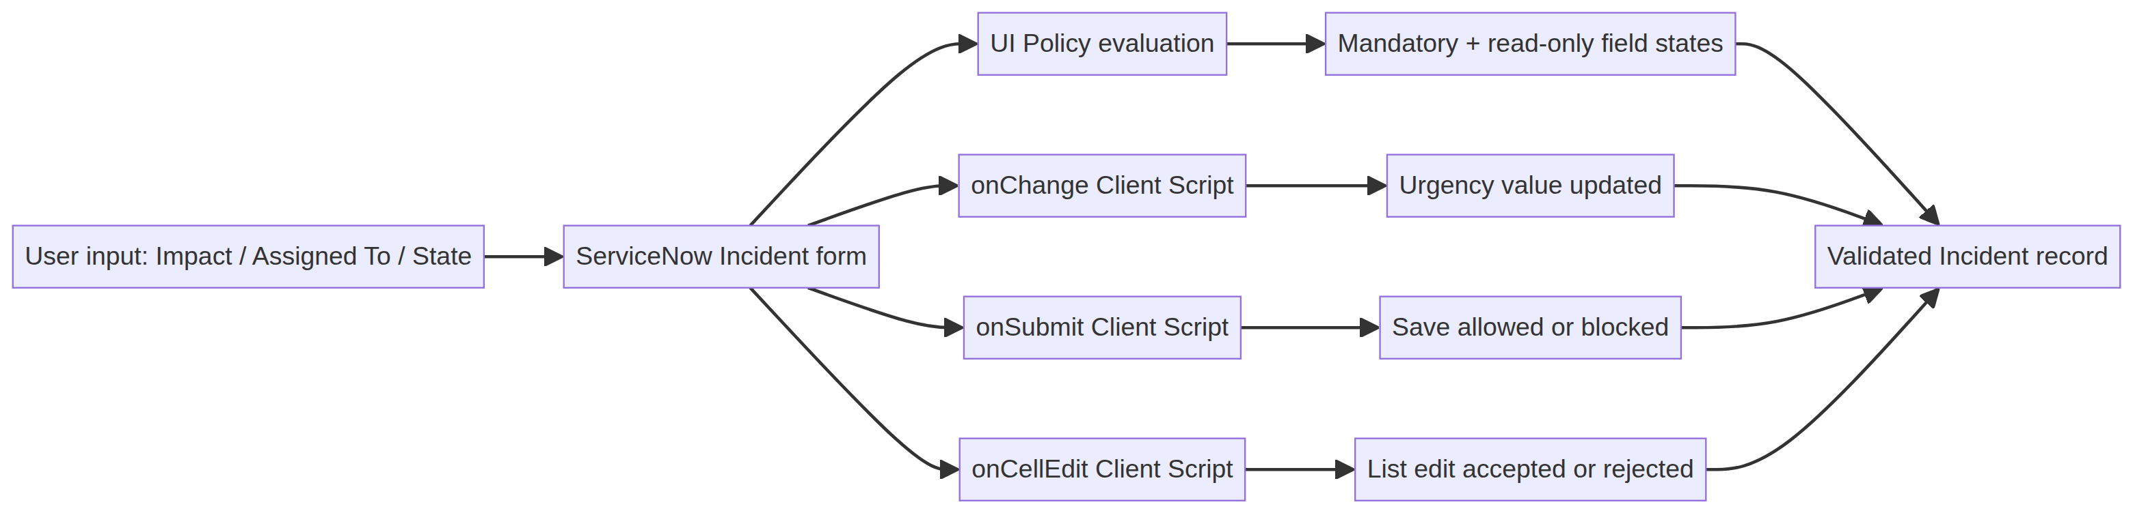
Figure 4. Data flow from user input through client-side controls to Incident outcomes.
3.4 Technology Stack
Layer | Technology / object | Role in project
Platform | ServiceNow | Hosts the Incident table, forms, lists, UI Policies, and Client Scripts
Data object | Incident table | Stores Impact, Urgency, Assignment group, Assigned To, and State values
Configuration | UI Policy and UI Policy Actions | Controls mandatory and read-only field behavior
Scripting | JavaScript Client Scripts | Implements onChange, onSubmit, and onCellEdit behaviors
Interface API | g_form and callback | Reads/sets fields, displays messages, and approves/rejects edits
4. PROJECT DESIGN
4.1 Problem Solution Fit
The solution fits the problem because each observed failure mode receives a direct control. Missing routing information is addressed by mandatory Assignment group. Priority inconsistency is addressed by setting Urgency when Impact becomes High. Incomplete ownership is addressed by blocking save when Assigned To is empty. Unsafe list editing is addressed by rejecting State changes through onCellEdit. The controls are conditional rather than global, so ordinary Incident editing remains flexible when Impact is not High.
4.2 Proposed Solution
The proposed implementation uses the following sequence: create the High Impact Control policy; configure its Assignment group and Urgency actions; add the onChange urgency script; add the onSubmit save validation script; add the onCellEdit State guard; and then verify all five documented test activities. The configuration is active and scoped to the Incident table.
4.3 Solution Architecture
Figure 5. Solution architecture showing the form, list, client-side control layer, and resulting Incident data outcomes.
5. PROJECT PLANNING & SCHEDULING
5.1 Project Planning
The implementation is organized into four planned work packages so configuration dependencies are completed before integrated verification. This schedule is a project plan based on the source PDF, not a claim that a live ServiceNow instance was executed during report preparation.
Work package | Scope | Estimated points | Planned completion | Exit condition
WP-1 Policy foundation | High Impact Control, Assignment group mandatory, Reverse if false, Urgency read-only | 7 | 06 Oct 2026 | Policy and actions reviewed
WP-2 Client automation | onChange urgency and onSubmit Assigned To validation | 8 | 12 Oct 2026 | Scripts active and walkthrough complete
WP-3 Interaction safety | onCellEdit protection for State list editing | 3 | 18 Oct 2026 | List edit rejection and form edit path defined
WP-4 Integrated verification | Five documented test activities and evidence capture | 5 | 24 Oct 2026 | Results recorded for evaluator handover
Total planned effort: 23 story points. The schedule prioritizes configuration foundations, then automation, then interaction safety, and finally integrated verification.
6. FUNCTIONAL AND PERFORMANCE TESTING
6.1 Performance Testing
The project PDF defines functional behavior rather than numeric load benchmarks. Therefore, performance testing for this micro project focuses on client-side responsiveness and rule scope: scripts should run only for their intended trigger, set or reject values without unnecessary server interaction, and provide immediate feedback on the form or list.
Test ID | Scenario | Expected functional result | Performance observation | Status basis
FT-01 | Impact changes to High | Urgency is set to 1 and info message appears | Single field-change response; no repeated action expected | Defined in source PDF
FT-02 | Submit with High Impact and empty Assigned To | Error appears and save is blocked | Validation occurs before record submission | Defined in source PDF
FT-03 | Submit with High Impact and Assigned To populated | Record saves successfully | No additional validation loop expected | Defined in source PDF
FT-04 | Impact changes High → Medium | Mandatory/read-only changes reverse | Policy response should be immediate | Defined in source PDF
FT-05 | State edited from Incident list | Alert appears and edit is rejected | Callback ends the list-edit action | Defined in source PDF
Measurement limitation: the supplied project PDF does not include timed response measurements, transaction volumes, browser matrices, or live execution logs. Those values should be recorded if formal performance evidence is required.
7. RESULTS
7.1 Output Screenshots
The supplied project PDF describes expected outcomes but does not include live ServiceNow screenshots. To avoid presenting invented runtime captures as evidence, this report uses original project-specific output visualizations and clearly labels them as behavior models. The actual UAT evidence should be captured from the configured instance during execution.
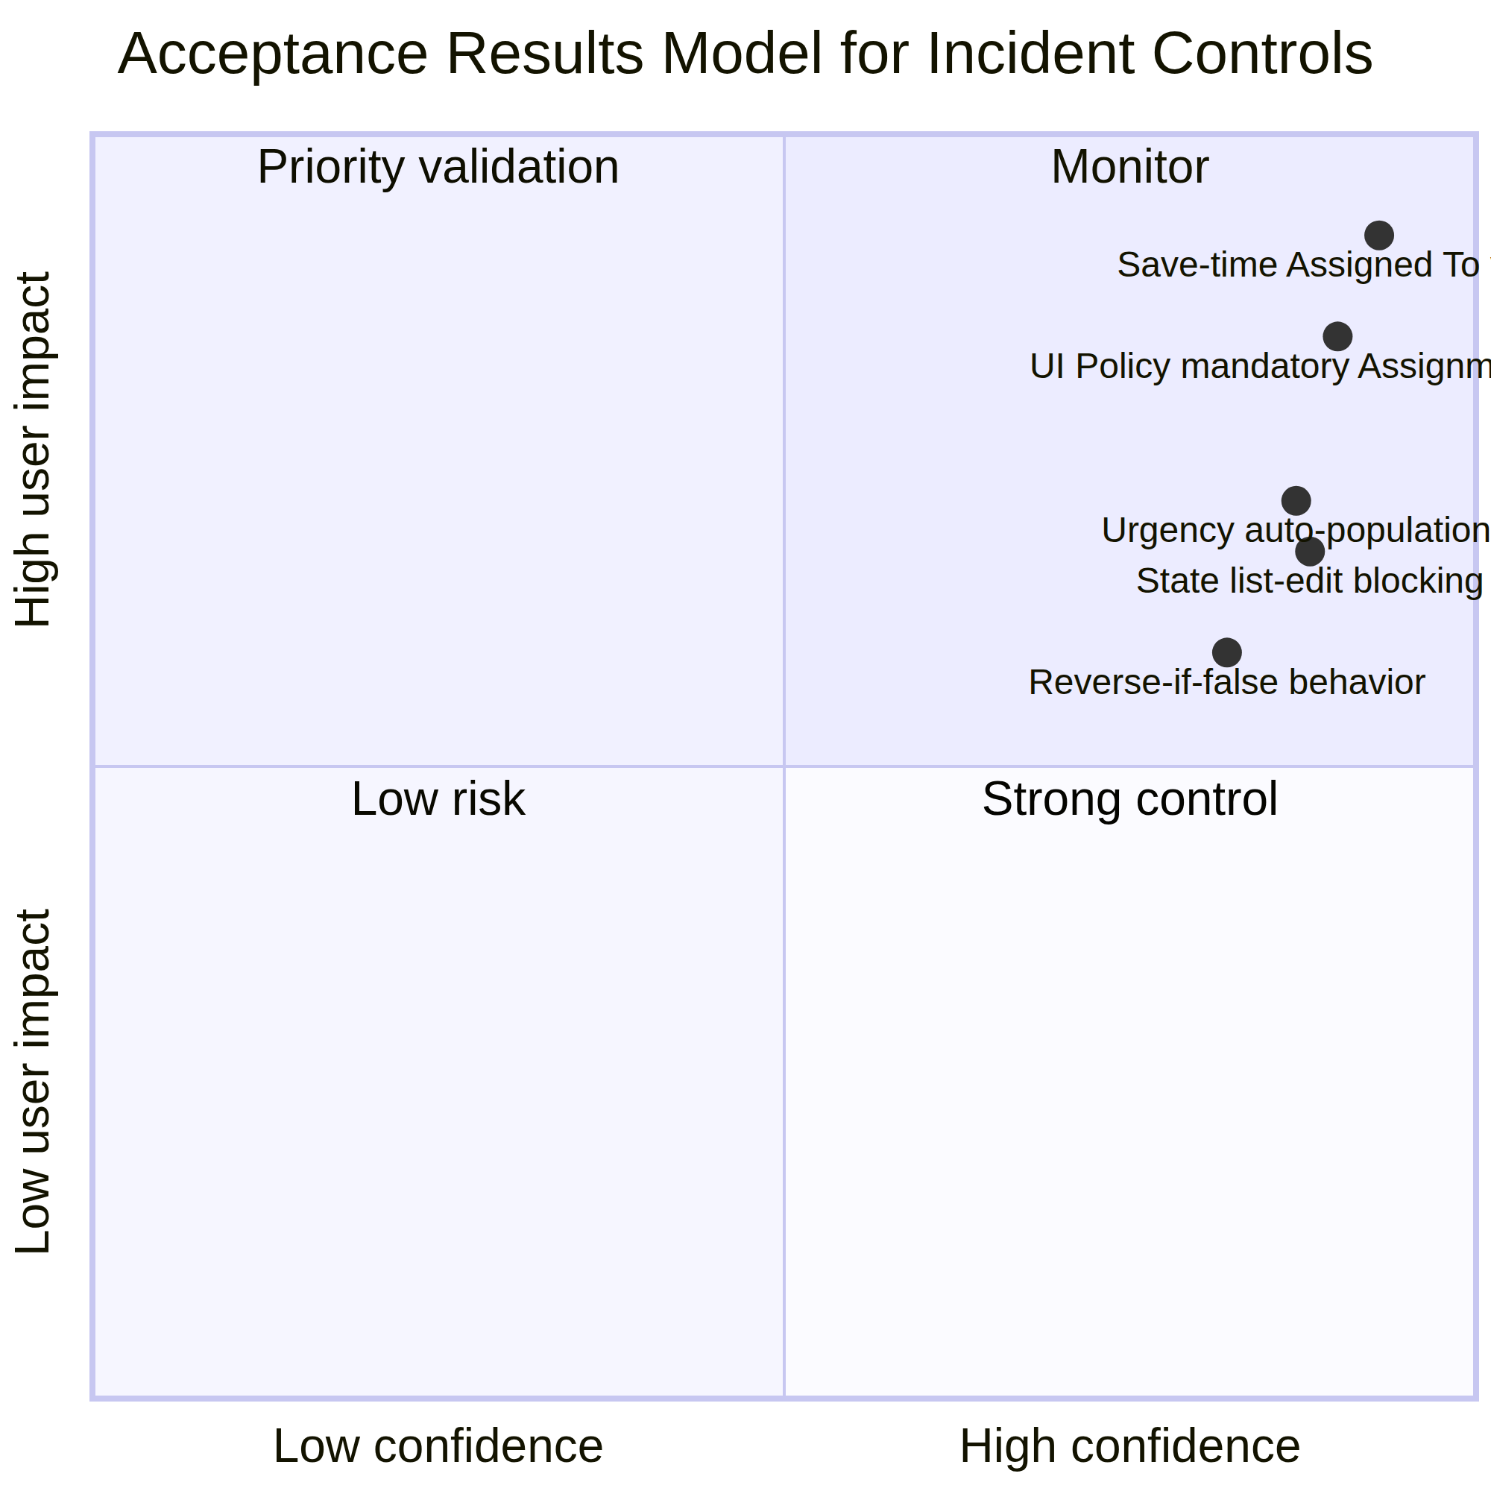
Figure 6. Project-specific results model mapping control confidence and user impact for the documented behaviors.
Output area | Expected result from project PDF | Evidence to capture during execution | Current report basis
High Impact Control | Assignment group mandatory; Urgency read-only | UI Policy record and Incident form screenshot | Expected behavior documented
Urgency automation | Urgency becomes High and info message appears | Incident form after Impact change | Script and expected result documented
Save validation | Assigned To error prevents save | Error message and unsaved Incident screenshot | Script and expected result documented
List edit protection | State change rejected from list | Alert and unchanged row value | Script and expected result documented
Successful updates | Form State update saves normally | Updated Incident record screenshot | Test condition documented
8. ADVANTAGES & DISADVANTAGES
Advantages | Disadvantages / constraints
Immediate guidance at the point of data entry. | Client-side rules can be bypassed by non-form integrations unless server-side controls are added.
High-impact records receive stronger routing and ownership controls. | The onChange script only runs on the client and depends on the form trigger.
Urgency is aligned automatically with Impact. | The current rule is intentionally narrow and does not cover every Incident business rule.
List-based State changes can be stopped without disabling form updates. | Alert-based list feedback may be less informative than a richer inline message.
Small, modular scripts are easy to review and maintain. | Formal performance metrics and live screenshots are not present in the source PDF.
9. CONCLUSION
The Implement Client Script & UI Policy (Incident) project provides a focused client-side control framework for improving Incident data quality. The UI Policy reacts to high impact, the onChange script aligns urgency, the onSubmit script prevents incomplete ownership information, and the onCellEdit script protects State from direct list modification. Together, these controls create a consistent and understandable user experience while preserving normal form-based updates when the high-impact condition is not active.
10. FUTURE SCOPE
- Add equivalent server-side validation so integrations and imports receive the same protection as the browser form.
- Replace the alert-based list-edit message with a standardized notification pattern and audit entry.
- Extend the policy to other combinations such as critical urgency, security incidents, or VIP callers.
- Add automated ATF coverage for all five documented test activities and regression execution.
- Capture response-time baselines and browser compatibility results for production readiness.
- Add role-based exceptions for approved administrators while preserving auditability.
11. APPENDIX
Source Code (from supplied project PDF)
The following code excerpts are reproduced from the supplied project PDF and correspond to the three Client Scripts implemented in the project.
// onChange — Auto set urgency for high impact
function onChange(control, oldValue, newValue, isLoading) {
if (isLoading || newValue == '') return;
if (newValue == '1') {
g_form.setValue('urgency', '1');
g_form.addInfoMessage('Urgency set to High for High impact incident.');
}
}
// onSubmit — Prevent save if Assigned To is missing
function onSubmit() {
if (g_form.getValue('impact') == '1' &&
g_form.getValue('assigned_to') == '') {
g_form.showErrorBox('assigned_to',
'Assigned To is mandatory for High impact incidents.');
return false;
}
return true;
}
// onCellEdit — Prevent State changes through list editing
function onCellEdit(sysIDs, table, oldValues, newValue, callback) {
alert('State cannot be updated using list editing. Please open the Incident.');
callback(false);
}
Dataset Link
Not applicable. This project operates on ServiceNow Incident records and does not use a separate downloadable dataset. The relevant data fields are part of the Incident table: Impact, Urgency, Assignment group, Assigned To, and State.
Report basis and evidence note
This report is based on the supplied file “ImplementClientScript&UIPolicy(Incident).pdf”. Diagrams in this report are original visualizations created for this project. Where the source PDF defines expected behavior without live screenshots or logs, the report identifies the limitation instead of inventing execution evidence.

